

***Name : Muhammad Naeem***

***Father name: Ishaq***

***Section :4***

***Email :falakakrbalai@gmail.com.pk***

***Contect :03414741754***

***Course : Data Sceience And Artificial Intillegence***

create schema retail_shop;

use retail_shop;

-- BEGINNER QUERIES

-- beginner_query_1. Definition of meta Data in mySQL Workbench

describe online_retail;

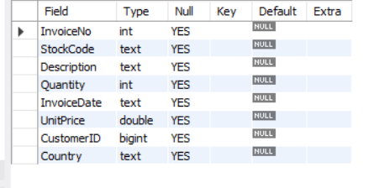

select * from online_retail;

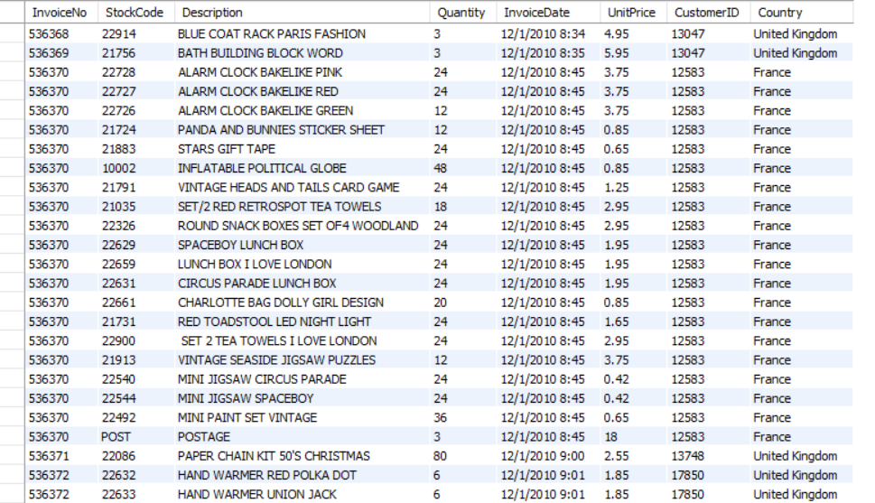



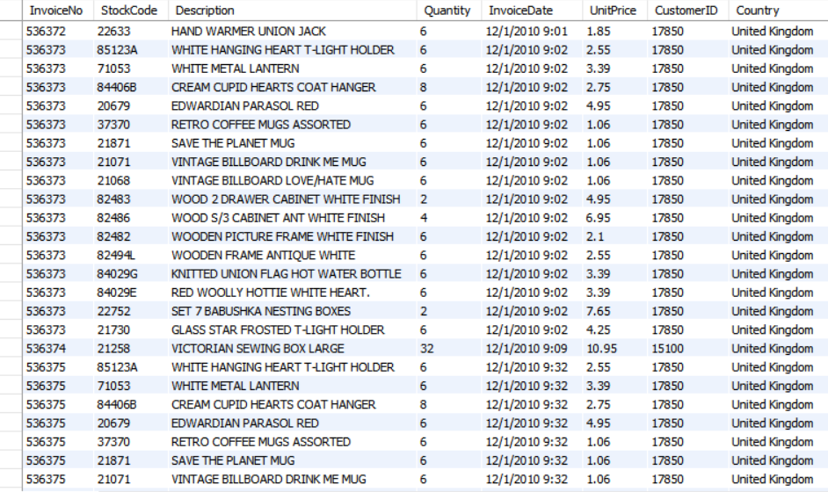

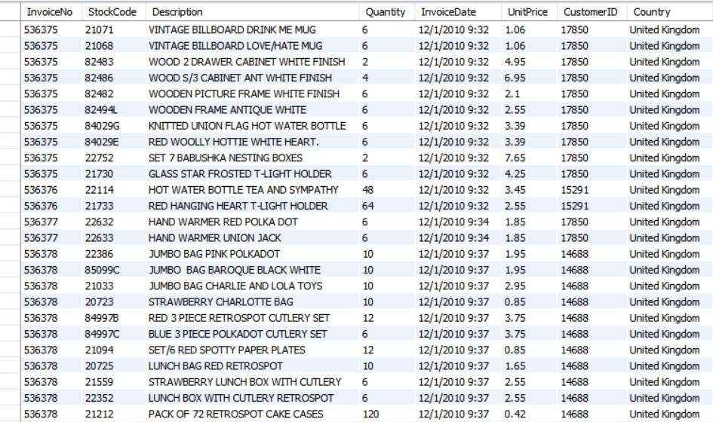

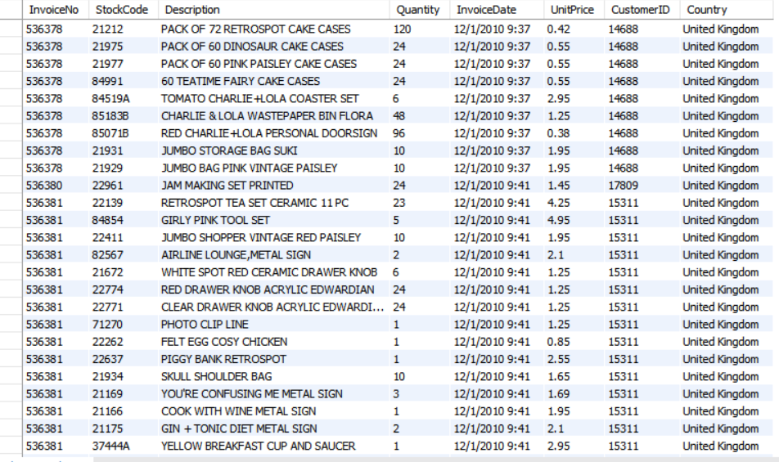

.

.

.

.

.

.

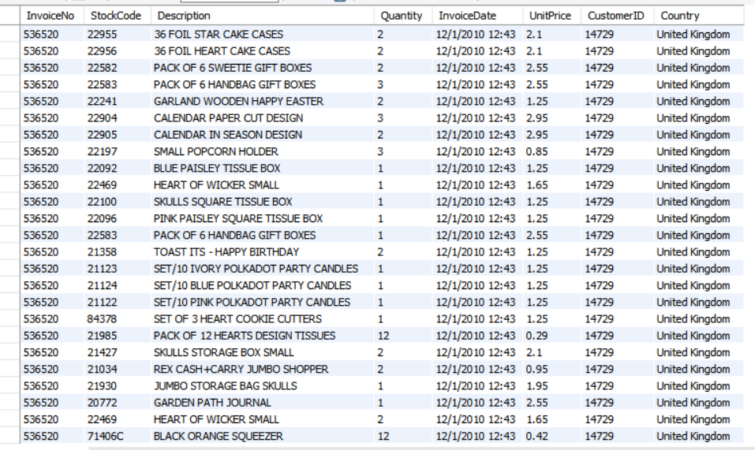

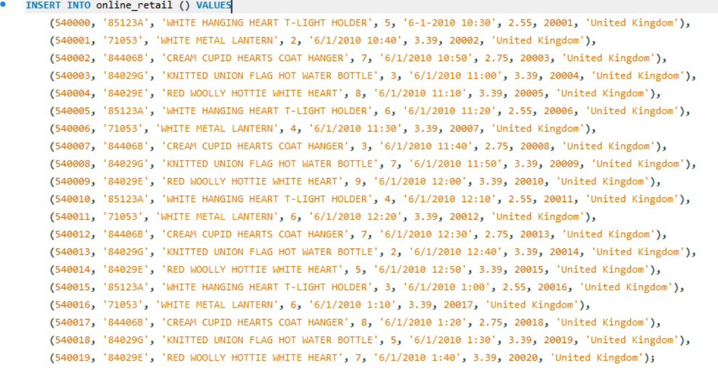

select * from online_retail;

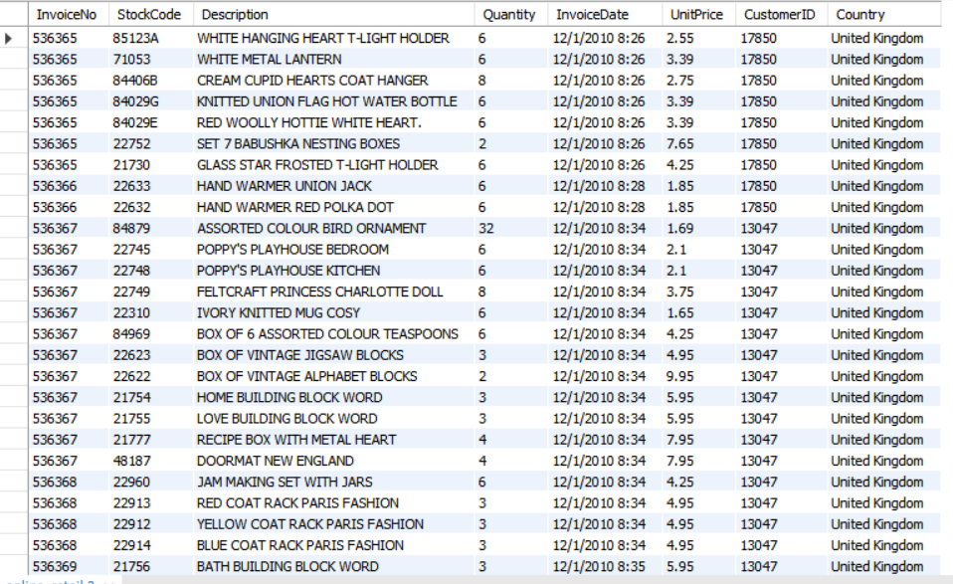

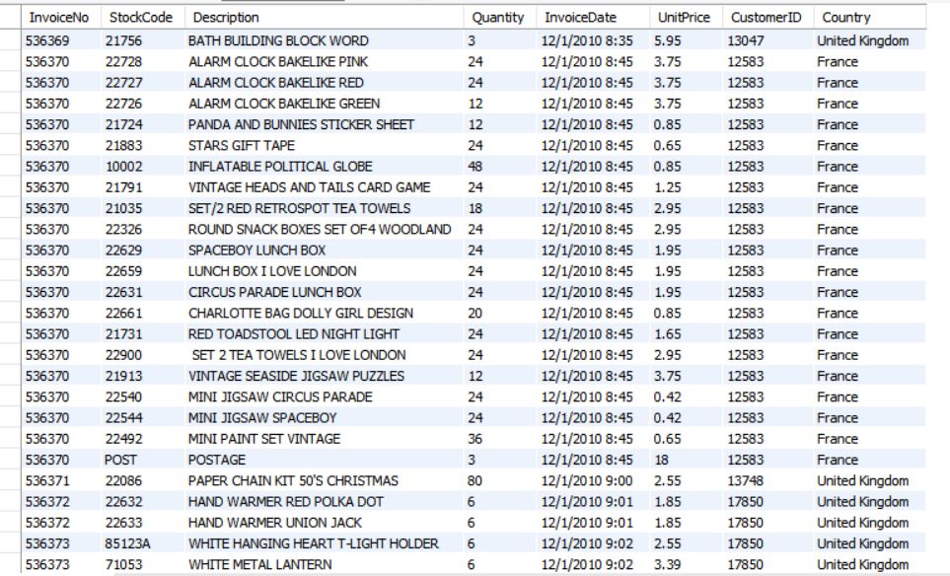

.

.

.

.

.

.

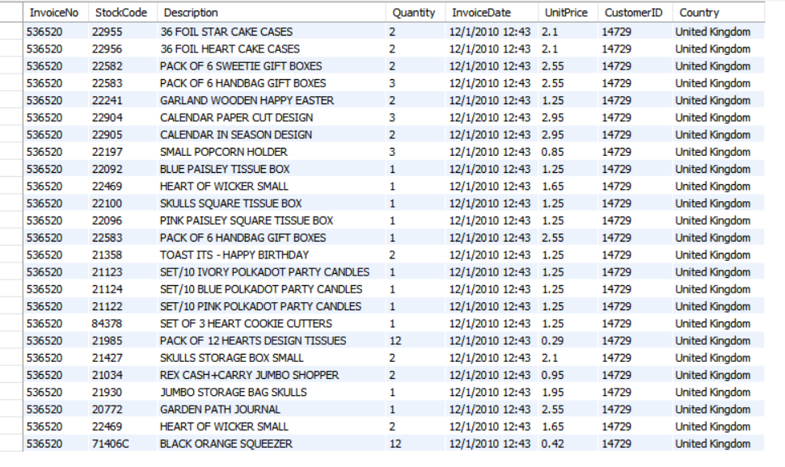

beginner_query_2. What is the distribution of order values across all customers in the dataset?

SELECT

Customer ID,

SUM(Quantity * Unit Price) AS Total Order Value

FROM

online_retail

GROUP BY

Customer ID

ORDER BY

Total Order Value DESC;

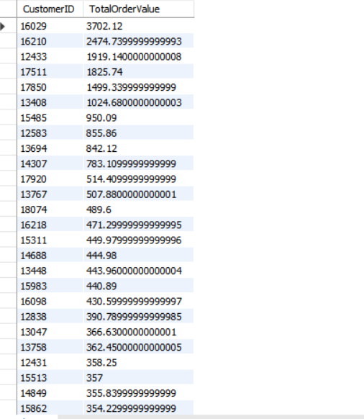

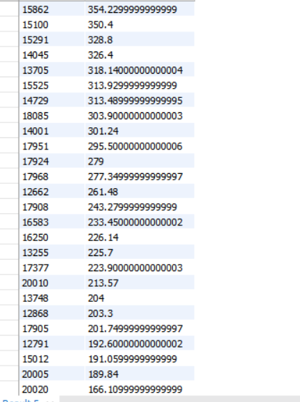

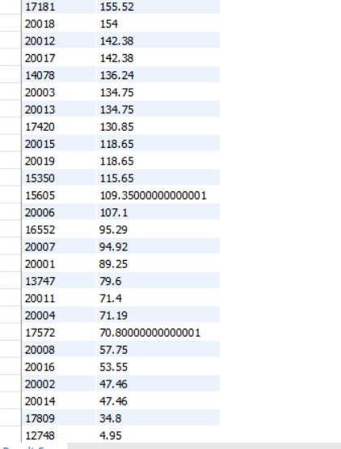

beginner_query_3. How many unique products has each customer purchased?

SELECT

Customer ID,

COUNT(DISTINCT Stock Code) AS Unique Products Purchased

FROM

online_retail

GROUP BY

Customer ID

ORDER BY

Unique Products Purchased DESC;

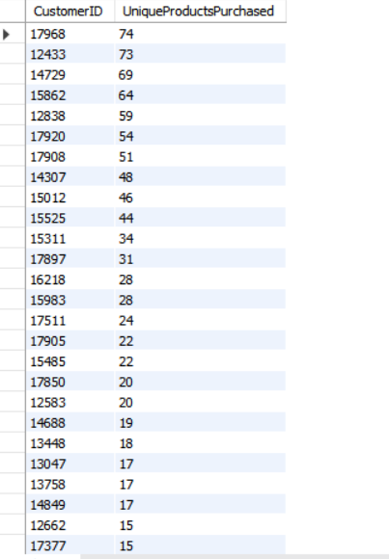

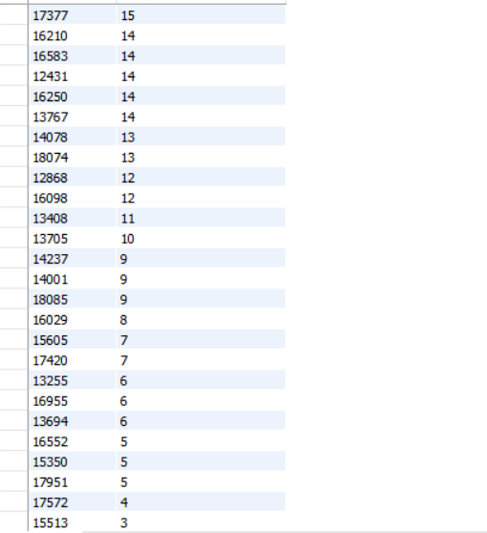

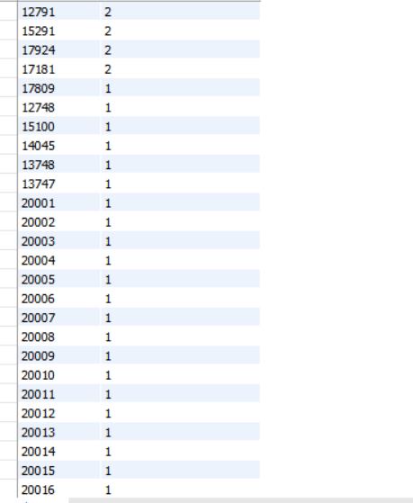

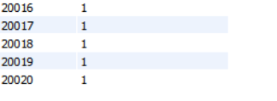

-- beginner_query_4. Which customers have only made a single purchase from the company?

SELECT

Customer ID

FROM

online_retail

GROUP BY

Customer ID

HAVING

COUNT(DISTINCT Invoice No) = null;

beginner_query_5. Which products are most commonly purchased together by customers in the dataset?

SELECT

p1.Stock Code AS Product1,

p2.Stock Code AS Product2,

COUNT(*) AS Frequency

FROM

online_retail p1

JOIN

online_retail p2

ON

p1.Invoice No = p2.InvoiceNo

AND

p1.Stock Code < p2.StockCode

GROUP BY

p1.Stock Code,

p2.Stock Code

ORDER BY

Frequency DESC;

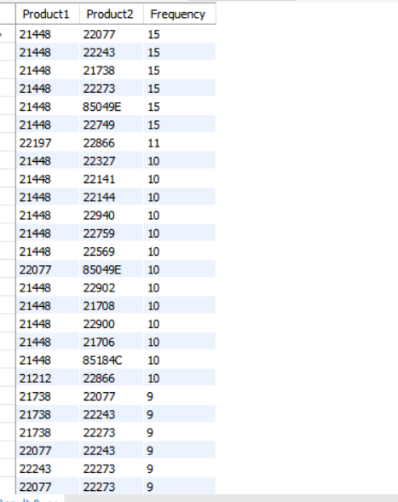

advanced_query_5. Time-based Analysis

-- Explore trends in customer behavior over time, such as monthly or quarterly sales patterns.

--

set SQL_SAFE_UPDATEs = 0;

UPDATE online_retail

SET Invoice Date = STR_TO_DATE(Invoice Date, '%m/%d/%Y %H:%i')

WHERE Invoice Date IS NOT NULL;

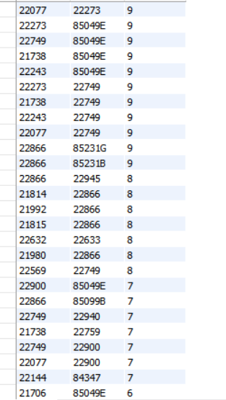

.

.

.

.

.

.

.

.

.

.

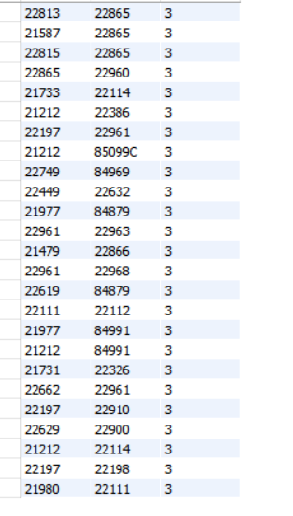

ADVANCED QUERIES

-- advanced_query_1. Customer Segmentation by Purchase Frequency

-- Group customers into segments based on their purchase frequency, such as high, medium, and low frequency

-- customers. This can help you identify your most loyal customers and those who need more attention

SELECT

Customer ID,

COUNT(DISTINCT Invoice No) AS Purchase Frequency,

CASE

WHEN COUNT(DISTINCT Invoice No) > 10 THEN 'High Frequency'

WHEN COUNT(DISTINCT Invoice No) BETWEEN 5 AND 10 THEN 'Medium Frequency'

ELSE 'Low Frequency'

END AS Customer Segment

FROM

online_retail

GROUP BY

Customer ID

ORDER BY

Purchase Frequency DESC;

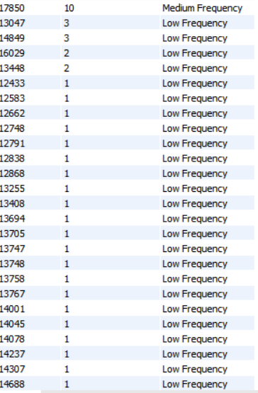

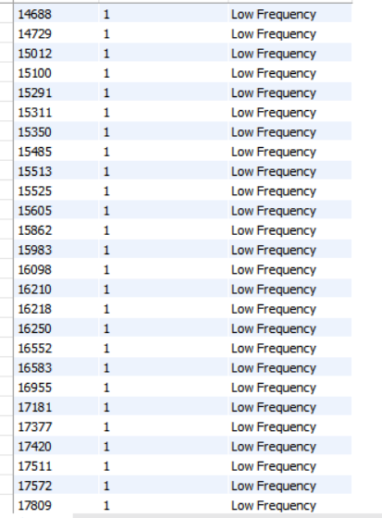

.

.

.

.

.

.

.

.

.

.

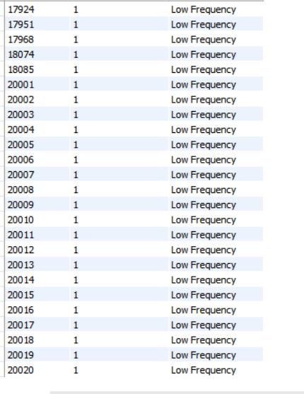

advanced_query_2. Average Order Value by Country

-- Calculate the average order value for each country to identify where your most

-- valuable customers are located.

SELECT

Country,

AVG(Order Value) AS Average Order Value

FROM

(

SELECT

Invoice No,

Country,

SUM(Quantity * Unit Price) AS Order Value

FROM

online_retail

GROUP BY

Invoice No, Country

) AS order_values

GROUP BY

Country

ORDER BY

Average Order Value DESC;

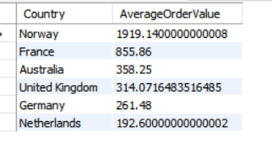

advanced_query_3. Customer Churn Analysis

-- Identify customers who haven't made a purchase in a specific period

-- (e.g., last 6 months) to assess churn.

SELECT

Customer ID,

MAX(Invoice Date) AS Last Purchase Date

FROM

online_retail

GROUP BY

Customer ID

HAVING

MAX(Invoice Date) < DATE_SUB(CURDATE(), INTERVAL 6 MONTH)

ORDER BY

Last Purchase Date DESC;

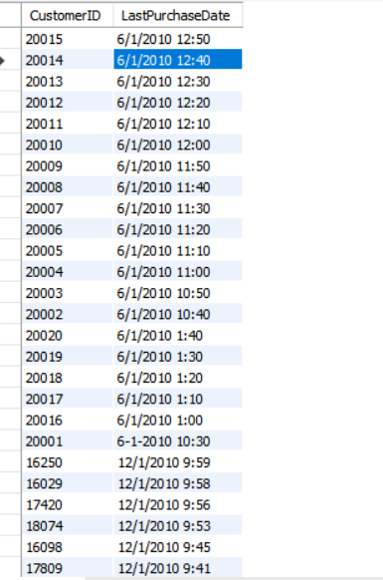

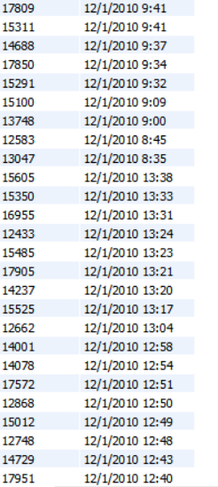

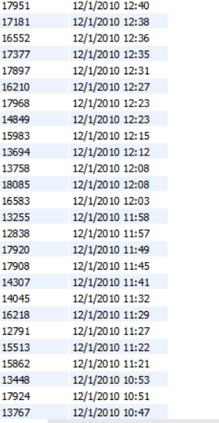

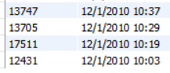

advanced_query_4. Product Affinity Analysis

-- Determine which products are often purchased together by calculating the

-- correlation between product purchases.

SELECT

p1.Stock Code AS Product1,

p2.Stock Code AS Product2,

COUNT(*) AS Frequency

FROM

online_retail p1

JOIN

online_retail p2

ON

p1.Invoice No = p2.InvoiceNo

AND

p1.Stock Code < p2.StockCode

GROUP BY

p1.Stock Code, p2.StockCode

ORDER BY

Frequency DESC;

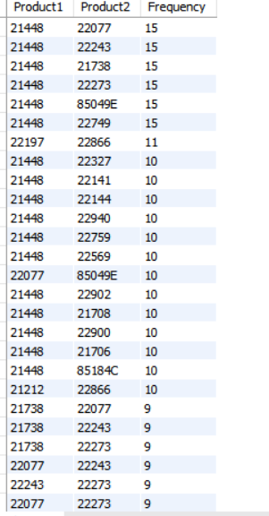

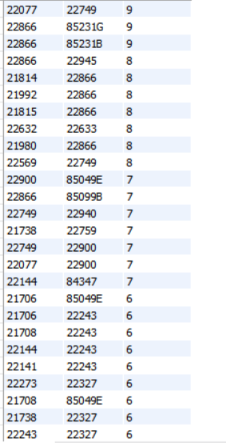

.

.

.

.

.

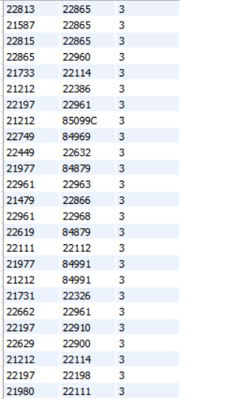

advanced_query_5. Time-based Analysis

-- Explore trends in customer behavior over time, such as monthly or quarterly sales patterns.

--

set SQL_SAFE_UPDATEs = 0;

UPDATE online_ retail

SET Invoice Date = STR_TO_DATE(Invoice Date, '%m/%d/%Y %H:%i')

WHERE Invoice Date IS NOT NULL;

SELECT

DATE_FORMAT(Invoice Date, '%Y-%m') AS Month,

SUM( Quantity * Unit Price) AS Total Sales,

COUNT( DISTINCT Invoice No ) AS Number Of Orders

FROM

Online_ Retail

GROUP BY

DATE_FORMAT(Invoice Date, '%Y-%m')

ORDER BY

Month ASC; 

***Thank YOU***